**Python Module-2**

**Exercises:**

1. Write a program that prints the numbers from 1 to 10 using a for loop.

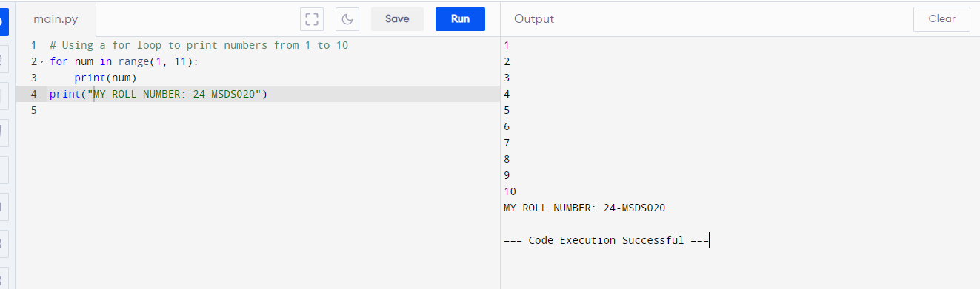

2. Write a program that prints the numbers from 1 to 10 using a while loop.

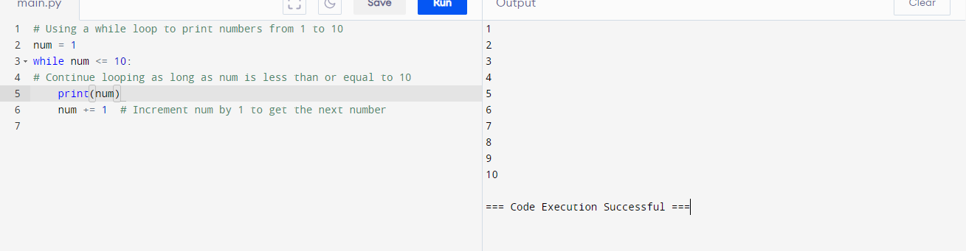

3. Write a program that prints the even numbers from 1 to 10 using a for loop.

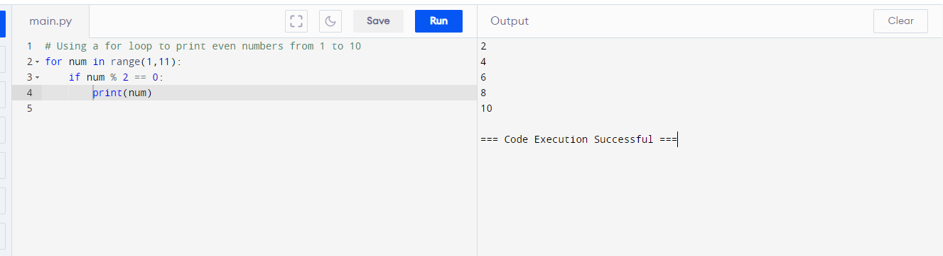

4. Write a program that prints the odd numbers from 1 to 10 using a while loop.

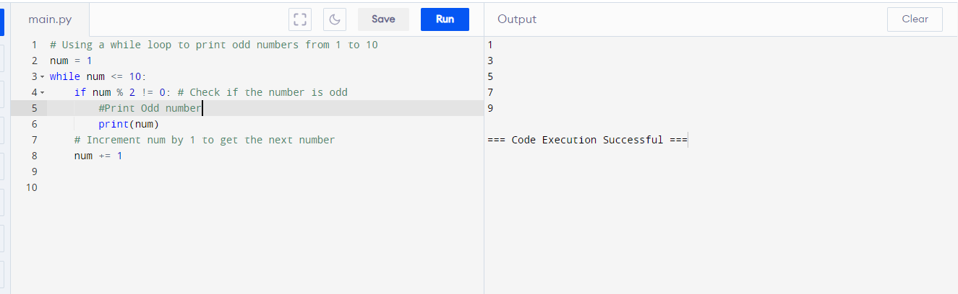

5. Write a program that takes a number from the user and checks if it is positive, negative, or zero using an if-elif-else statement.

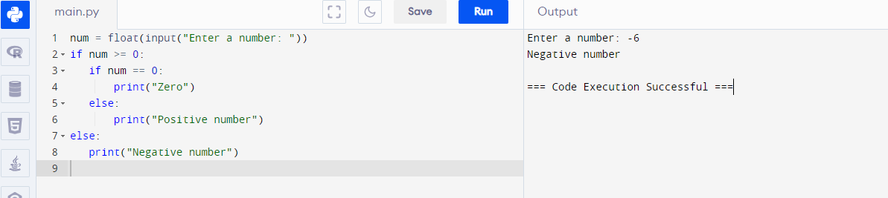

6. Write a program that takes two numbers from the user and prints the largest of the two using an if-else statement.

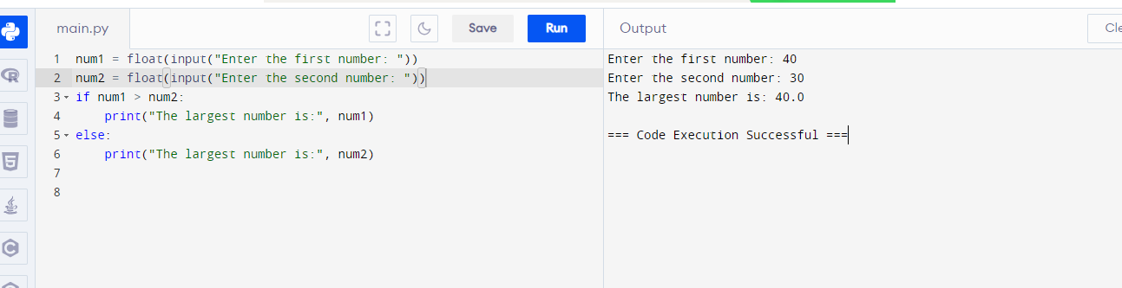

7. Write a program that takes a list of numbers from the user and prints the sum of all the numbers using a for loop.

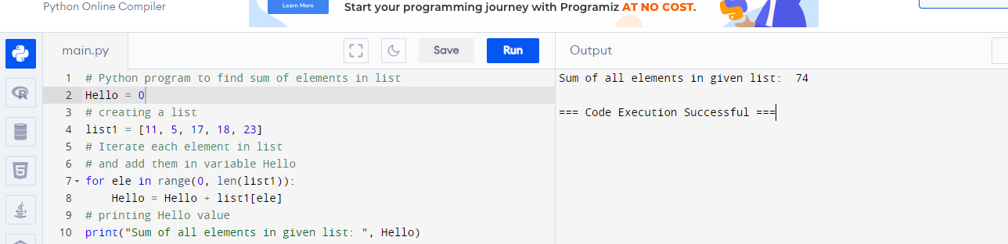

8. Write a function to remove duplicates from a list while preserving the order.

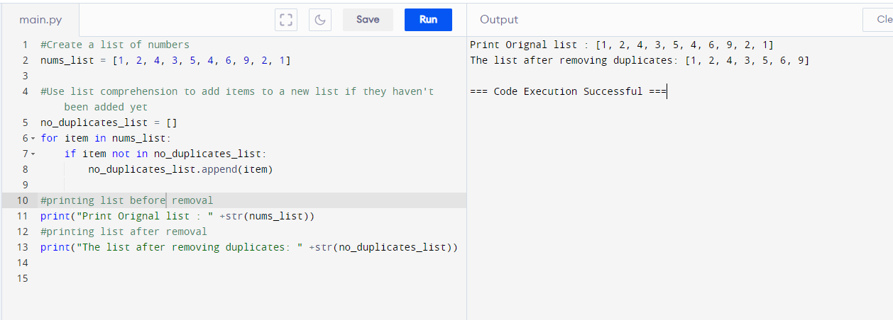

9. Write a function to find the second largest number in a list.

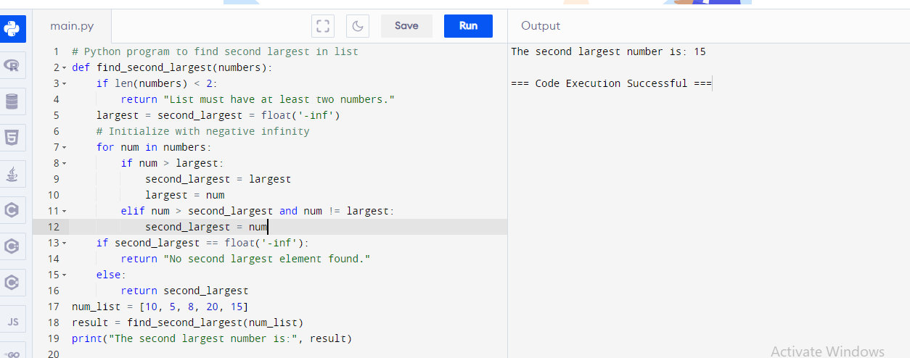

10. Write a function to count the frequency of words in a string using a dictionary.

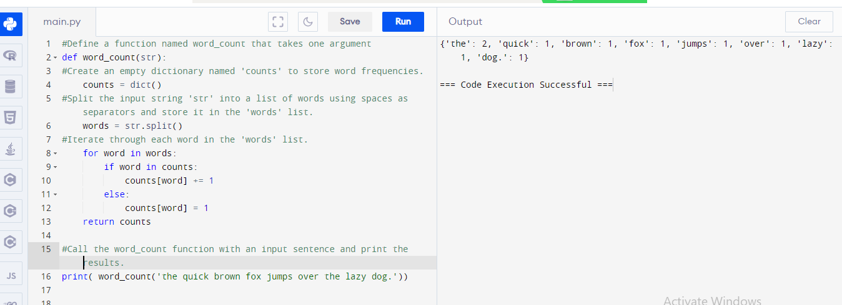

11. Write a function to find the common elements in two dictionaries.

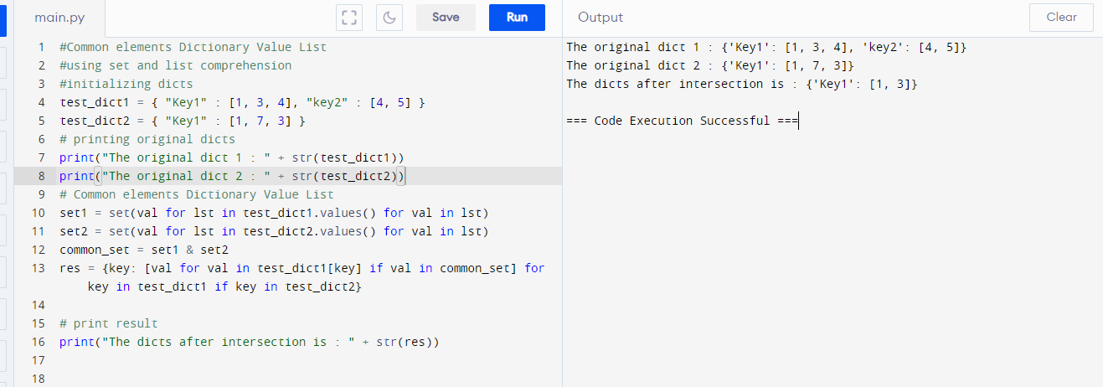

12. Write a function to find the top N items in a dictionary based on their values.

